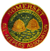
Somerset Beekeepers’ Association
NEWSLETTER
January 2020 no.139
Please send any copy for the April 2020 edition to me by 15th March
Email: friend.elizabeth@gmail.com.

Letter from the Chairman.

At this time of the year there is a temptation to look back but, as all good beekeepers know, now is the perfect time to plan for the coming season. And it is the same for SBKA.

A new education support group, working under the auspices of our education officer Richard Bache MB, is getting going. The group will run a two-day queen rearing course in the Spring – more details to follow.

Group members will write articles for this newsletter and the website with an educational focus – in this issue Tricia Nelson MB writes about the importance of temperature to a colony.

Details of our annual Lecture Day in February, AGM and Special Lecture are published on these pages and, once again, there is an interesting line-up of speakers who will both inform and entertain.

On the Asian hornet front, our AHAT coordinator Lynne Ingram MB and others are running a conference for the South West Beekeepers’ Forum in January to assist AHAT members across the region to be as well prepared as possible. Meanwhile, Richard and Lynne are looking at new ways to help us all become more knowledgeable about identification.

We would still like new people to join the small team which runs SBKA. We’re looking for a new treasurer and vice chairman (from the AGM in March) and an events secretary to handle publicity and tickets. More details are on the website or get in touch.

And that just leaves it for me to wish you all a very happy New Year.
Anne Pike, Chairman.

FORTHCOMING EVENTS

South West Asian Hornet Action Team Convention
Organised by SBKA on behalf of South West Beekeepers Forum
Venue: Canalside, Marsh Lane, Bridgwater TA6 6LQ
Date Saturday January 25th, 2020
Registration: 9.30
Times: 10.00 - 5.00

An opportunity for the South West AHATs to come together to review the year; hear the latest research on Asian Hornets; update skills and learn new ones; share good practice and make plans for working together as best we can.
Speakers include Dr Peter Kennedy and Dr Sarah Bunker
Presentations & workshops
Workshops include - The role of first responders
The behaviour of Asian Hornets in the field
Practical skills
AHAT Coordinator sessions
Education and publicity
Tool kits
Radio telemetry
Displays
Cost: £5 to cover refreshments
Bring packed lunch or order sandwiches from Canalside - info@thecanalside.co.uk
Tickets are available on line
Or by sending a cheque payable to SBKA with a SAE and advising which AHAT Team you are connected with, to
SBKA Treasurer
Allways
West Shepton
Shepton Mallet
BA4 5UH

SBKA Lecture Day

Saturday 15th February 2020
9.00am - 5.00pm
Edgar Hall, 8 Cary Court
Somerton Business Park, TA11 6SB

Programme
9.00 Coffee

9.30 Opening by Jackie Mosedale, President of SBKA.

9.35 Through winter into spring. Clive de Bruyn

10.40 Honey Bee mind/navigation. Prof. Lars Chittka

11.40 Coffee

12.10 Bee stings. Dr. Nikos Tsiougkos

1.10 Lunch.
During this time Lynne Ingram and other AHAT members will be available to talk about the Asian Hornet and help with your queries on the current situation.

2.20 Thanks and Presentations

2.30 How to make Mead and Melomels. Dinah Sweet

3.30 Raffle and Tea

4.00 What I have learned from Beekeeping in the past fifty years. Clive de Bruyn

5.00 Close

Tickets are £5 and include tea and coffee.
To book on line via Eventbrite please click here.
Alternatively, you can send a cheque for £5 per ticket made payable to
SBKA together with a S.A.E., to The Treasurer, Allways, West Shepton, Shepton Mallet, Somerset, BA4 5UH

PLEASE bring your own lunch

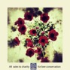
You may be interested to know that Prof Chittka has compiled a concept music album in which all song lyrics are inspired by his work on the world of bees and their interactions with flowers with all the proceeds going to Buglife: https://killerbeequeens.bandcamp.com/releases.

Clive de Bruyn FIBKA Snr., BBKA Snr., N.D.B.
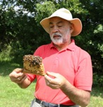
Clive has been a beekeeper since the 1960’s. He is one of the best-known and respected beekeeping authorities in Britain and Ireland. Based in Essex, where he runs over 100 colonies for queen-rearing, honey production and pollination. He is a prominent member of the Bee Farmers’ Association, where he has been the Education Officer since 1982. As well as being a bee farmer Clive has studied, worked and presented papers within an international forum for many years and done much work in third world countries. In addition, he has written several books including the indispensable “Practical Beekeeping”.

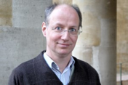
Prof Lars Chittka FLS, FRES, FSB is a German zoologist, ethologist and ecologist distinguished for his work on the evolution of sensory systems and cognition, using insect-flower interactions as a model. He is also the founder of the Research Centre for Psychology at Queen Mary University of London, where he is a Professor of Sensory and Behavioural Ecology. Chittka has carried out extensive work on the behaviour, cognition and ecology of bumblebees and honeybees, and their interactions with flowers. He developed perceptual models of animal colour vision, allowing the derivation of optimal receiver systems as well as a quantification of the evolutionary pressures shaping flower signals. Chittka also made fundamental contributions to the understanding of animal cognition and its fitness benefits in the economy of nature. He explored phenomena such as numerosity, speed-accuracy trade-offs, false memories and social learning in bees. His discoveries have made a substantial impact on the understanding of animal intelligence and its neural-computational underpinnings. He has published over 250 peer-reviewed articles, many of them highly cited.
Dr Nikos Tsiougkos is an Allergy specialist and has been working in the UK in the last 5 years. He obtained his Specialty (Allergy and Clinical Immunology Degree) degree in Athens/Greece and holds a certificate of excellence in Allergy having sat the European Examination in Allergology and Clinical Immunology (EAACI/UEMS). He has a master’s Degree in “Clinical Applications of Molecular Medicine”/ University of Thessaly, Greece. He speaks 4 languages and in his spare time he enjoys travelling and collecting fine art.

Dinah Sweet started her beekeeping with husband John, 40 years ago. Dinah Sweet completed a Diploma dissertation in Apiculture at Cardiff University on melissopalynology (the study of pollen grains in honey) supervised by the legendary Rex Sawyer, author with Robert Pickard of “Pollen Identification for Beekeepers”. Since then she has been examining honeys for commercial packers and giving talks on the topic to Beekeeping Associations. She has held positions within BIBBA and the Welsh Beekeepers Association and often gives talks. She wrote the National Honey Show booklet on Mead for showing and drinking She has been judging mead at the NHS for the last 10 years and also recently finished a number of years, working as a bee inspector.

SBKA Annual General Meeting 2020
Hosted by Yeovil and District Division
28th March 2020
Venue: Frogmary Green Farm, West St, South Petherton TA13 5DJ
Lunch
Lunch will be two courses, costing £14.50. Booking for lunch should be made by sending a cheque payable to ‘SBKA Yeovil Division’, stating your choice of menu options for both main course and dessert to:
Sharon Blake, Stratton Court, Over Stratton, South Pethetrton,TA13 5LQ by 21 March 2020.

Menu
Beef and Cider Casserole, served with seasonal vegetables and potatoes.
Chicken Parmesan, served with potatoes and mixed salad or seasonal vegetables.
Vegetable Lasagne, served with mixed salad and specialty herb bread.

Followed by a choice of:
Lemon Passion or Blackberry and Apple Crumble with cream or ice cream
And tea or coffee.
Special dietary requirements can be catered for if advised by 21 March 2020.

Timetable
12noon – Frogmary Green Farm will be open for guests to arrive and purchase their own drinks from the bar upstairs.
12.30pm – Lunch
2pm - Welcome by the SBKA President.
2.05pm – Lynfa Davies, Master Beekeeper, NDB.
Nucleus Colonies:Their Many Uses. What are nuclei and how do they contribute to our beekeeping?
3.15pm - Tea or coffee.
3.30pm AGM

We asked Lynfa to introduce herself:
“I live in Mid Wales where Rob and I are part of Aberystwyth and District BKA. I have been keeping bees for 15 years after Rob bought me a week's beekeeping course as a birthday present. I was immediately hooked and over the years worked my way through the BBKA modules to become a Master Beekeeper in 2015. This year I passed the National Diploma in Beekeeping.

I have 20ish hives (if Rob asks it is a dozen!!) that are on Nationals with most of them on double brood. We have had two exceptionally good seasons; we thought last year was amazing but this year has almost equalled it despite the weather being more unstable.

I rear my own queens and sell a few nuclei locally. I really enjoy teaching new beekeepers and sharing what I have learned with others and hopefully help make a difference to their beekeeping. When I am not with my bees I can usually be found on my bike cycling up all the hills near my home or going for a dip in the sea. “

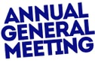
The AGM is an occasion which all members of SBKA are welcome to attend. It is an occasion that affords members the opportunity to hear an interesting lecture, meet members from other divisions and to have a say in how the association is run. Please make a note in your diary to attend the AGM and help SBKA to continue to be a successful beekeeping association.

Directions to Frogmary Farm:
From the M5: Exit at junction 25 and take the A358 towards the A303. At the Southfields roundabout with the A303, take the first exit and travel east on the Ilminster bypass. At the east end of Ilminster by pass take the fourth exit from the roundabout, passing the Esso garage on your left. On for 1.1 miles to the first mini roundabout where you turn right. Frogmary Green Farm is on the left after .6 mile.

From the A303: At the east end of Ilminster bypass take the fourth exit from the roundabout, passing the Esso garage on your left. On for 1.1 miles to the first mini roundabout where you turn right. Frogmary Green Farm is on the left after .6 mile.

Do not use your SATNAV for the last part; please follow the directions above. If you have any problems finding the venue, please phone Frogmary Green Farm on 01460 249758.
There is plenty of parking at Frogmary Green Farm.

Draft AGM Agenda
- Apologies
- To Approve the Minutes of the 2019 SBKA AGM
- Matters Arising from the Minutes
- Treasurer's report and adoption of charity accounts for year end 30 September 2019
- Election of Officers
- Election of Executive Divisional Representatives
- Appointment of independent reviewer: Bruton Sweet
- West Country Honey Farms Award
- Honorary Membership

Honorary Membership
Do check whether any of your members are eligible for honorary membership which is awarded for anyone who has had continuous membership of SBKA for 30 years.

West Country Honey Farms Award: We all know members who have given a huge commitment to beekeeping in Somerset. Each year, the West Country Honey Farms award recognises the contribution of a member. Last year, there were several nominations but some had such little detail that the committee really was unable to consider them.

It is time to call for nominations again, so please give your nominee support by detailing their contribution, for instance, what they have done within the Division, have they helped with mentoring, training, encouraging new beekeepers. Have they helped introduce young beekeepers to the craft? What has their contribution been beyond the division, county delegate, participation in organising and assisting at county events, shows such as the Bath & West Show.

Give the committee as much detail as you can but in as succinct form as possible.

Please send nominations to Jackie Mosedale no later than 31st January. This will enable the committee to meet together, assess each nomination and agree on who merits the award. If you require any further information, please contact Jackie Mosedale on
Jackiemosedale@gmail.com

Special Lecture
Wednesday 22 April 2020

Processing Beeswax
A talk by Ken Basterfield
At Edgar Hall, 8 Cary Court,Somerton Business Park, Somerton, TA11 6SB
19.00 Registration
19.30 start till 21.30
Free entry – Tea and coffee will be provided and there will be a raffle
Book on line or tickets can be obtained by sending a SAE to from County Treasurer, Allways, West Shepton, Shepton Mallet, BA4 5UH.
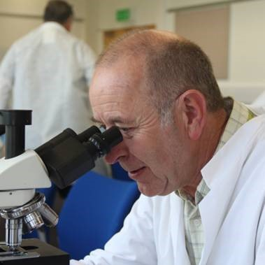
Ken Basterfield B.Sc.(Hons), C .Eng. MIET, NDB
Ken was first introduced to bees at 6 years old but began beekeeping upon graduating in 1971. He increased in numbers until running 150 colonies by 1979, running these as a semi-commercial outfit in parallel with his day job.
Ken took his BBKA Preliminary, Intermediate, Senior and Senior Practical certificates, before obtaining his National Diploma in Beekeeping (NDB) in 1996. During that time, he completed a wide range of beekeeping including stock selection and breeding from the best locally adapted performers and extensive queen raising. Ken has tried out most of the management techniques on large scale trials leading to ‘best fit’ tools and techniques for his own beekeeping environment.
His son Daniel returned to continue the beekeeping business in 2005.
Ken is a member of Devon BKA, and has held positions as Apiary Manager, County Show Chairman, Bee Farmers Association, a founder member of the Devon Agricultural Research Group (DARG), 1979, Examiner for BBKA Basic, General & Advanced Husbandry and for National Diploma in Beekeeping candidates. He is a member of the BBKA Examination board, a BBKA Trustee and has been a member of the NDB board.

County Queen Rearing Course
Tricia Nelson, Lynne Ingram, Alan Nelson and Bridget Knutson will be arranging a queen-rearing course at the end of April. This will take place at te Quantock apiary. Numbers will be limited so booking will be required. Further details will be sent out when the course has been finalized or contact any of the above for more information.

The Royal Bath and West Show
28th May – 30th May 2020
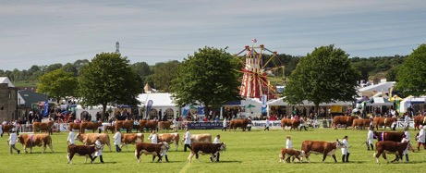
This event is a great opportunity to showcase Somerset Beekeeping. It forms an integral part of our promotion and education of bees and beekeeping skills to the public helping us comply with our charitable objectives.

For many years this has been organised by a few members on behalf of SBKA with help from stewards assisting on the day. It’s a good day out and a good networking opportunity for members. As usual we are looking for helpers at the event.

Without your help and enthusiasm, it would be impossible to maintain the high standards set in the Bee & Honey Marquee so please put these dates in your diary now.

Setting up will take place on Sunday, 24th May, and Stewards are required to man stands in the Marquee on the following three days,
Thursday 28th May, Friday 29th and Saturday 30th May.
The rota for stewards is either all day, 9.00am to 6.00pm, or a half-day, 9.00am to 1.30pm or 1.00pm to 6.00pm.

If you can help with setting up and/or stewarding, please contact me on 01373 228226, or e-mail me, tredg@talktalk.net. Your help will be very much appreciated.

Ken Tredgett

I’m sure that everyone who, like me, has volunteered in the past will agree when I say that we’ve always had a very enjoyable time. Ken organises everything with his usual efficiency and it’s fun to interact with all the people who come to the tent. People love seeing what we get up to and are always interesting to talk to so do please come and give a hand this year. T
he more the merrier. Liz Friend

Past events

National Honey Show
24-26 October 2019
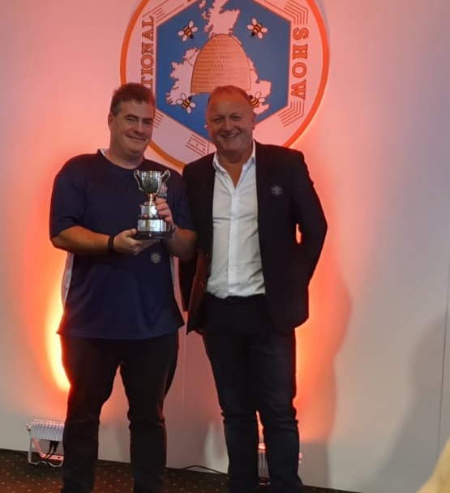
Mark and Christine Gullick (Burnham-on-Sea division) triumphed at the National Honey Show when they were awarded a trophy and lots of prize cards.
Their success reflects their skills both as beekeepers and the care and hard work they put in over the past season to produce so many very high quality exhibits.
The photo shows Mark receiving the Burnett cup from a representative of new show sponsor Kerax.

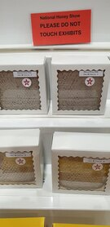
They received the Burnett cup after being placed first with their two section squares (photo left) in the open class and were placed in 15 of the 22 classes they entered.
Their results:
1st for 2 section squares in the open class and the David Burnett cup.
1st for Natural crystallised honey in the open class
1st for soft set in the NHS class.
2nd for honey for sale display open class
2nd for beeswax flowers
2nd for a honey jar label
3rd for a beeswax cake in the NHS class
3rd for 1 section square in the NHS class
3rd for a frame suitable for extraction in the open class
4th for soft set honey in the open class
VHC in a "for sale" display of honey (extracted comb and beeswax)
HC in the open light honey class
HC in the three different types of honey class
HC in the two jars of dark honey NHS class
HC in the display of home produced products

But they weren’t our only winners:

Catherine Fraser (pictured left) won HC’s for her two jars of chunk honey, her naturally crystallised or soft set honey and also for her 2 square sections.

Joe Parker won HC in class 87 (decorative or artistic exhibit) and for his box of honey sweets.

Congratulations to all those who took part.

Honey Shows: don’t forget that the winter is an excellent time to start planning which honey shows you want to enter in 2020. Not everyone can be as good as the winners above but the people who organize the shows appreciate everyone who has taken the time to enter and - after all - it’s the taking part that counts!

The 2020 County Honey Show
will again be held at Vivary Park as part of Taunton Flower Show
on 7th – 8th August
The rules are being revised and I understand that there will be some new classes.

Details will be in the next newsletter.

Somerset Beekeepers’ Annual Lunch 2019
Held on 17 November

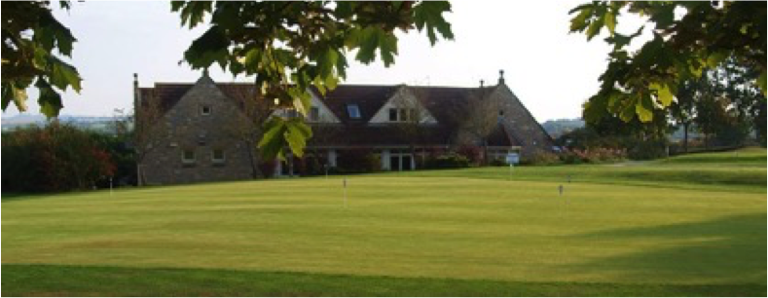

Members enjoyed an excellent lunch at Long Sutton Golf Club.
Very many thanks to Suzy Perkins for organising this for another year.

Other News

Honey Survey
Somerset beekeepers reap the rewards of a good season

SBKA members have more colonies at the end of the season than at the beginning and most enjoyed an excellent harvest according to our annual members’ survey.
Summary: On average a member has five colonies going into winter (one more than in the Spring), harvested up to 50 lbs per productive colony and 175 lbs in total.
Based on the findings provided by the 222 members who completed the online questionnaire, the total membership harvested more than 134,000 lbs from nearly 4,250 colonies.
Sixty per cent of respondents said the harvest was greater than last year and 44 per cent said it was more than average.
Forty-six per cent of members reported more swarms than last year, 25 per cent more wax moth and 20 per cent more absconding queens.
Only six per cent of members migrate their colonies for pollination and/or heather.

Survey results: Q1. How many Colonies did you have coming into the 2019 season?
The average number of colonies was 4. Some respondents had none as they were new beekeepers, the maximum was 80. In total there were 976 colonies

Q2. How many colonies do you now have going into winter?
The average number of colonies was 5. Some respondents had none, the maximum was 80. In total there were 1079 colonies

Q3. Average harvest per productive colony

Q4. How many pounds of honey did you harvest in total?
The results varied from a few with Nil to one respondent collecting 5,000 lbs
The average collection was 175 lbs and the total collected from respondents was 34,125 lbs

Q5. Is your harvest more or less than last year?

Q6. Is your harvest more or less than your average year?

Q7. Did you harvest a spring crop?
37% did have a spring crop and 63% didn’t.

Q8. Do you migrate your bees during the season? If yes what forage?
Only 3 respondents migrate their bees and the forage was OSR.
Q9. Did you have more swarms than last year?

Q10. Did your colonies suffer from any of the following:

:
Q11. Did you lose any nucs/colonies because of the following:
Q12. Is there anything else you would like to say about this year’s season?

Other comments included comments about the early start to the season because of the weather and the long summer which helped crops.

Research into Somerset EFB strain
A PhD research project into EFB, including the strain which is found in Somerset, is one step nearer to getting underway following the news that BDI is match-funding our £2,000 per year contribution and FERA has agreed to fund the remainder of the cost.
Annual updates throughout the project’s duration is a condition of our contribution and we will share them with you.
An outline of the work can be found on our website: Characterisation and quantification of secreted factors from strains of the honey bee brood pathogen, Melissococcus plutonius (EFB): Supervisors: Kirsty Stainton at Fera Science Ltd. and Thorunn Helgason at University of York.
Link here

Year Book Survey
Thank you to everyone who took part in our recent year book survey – 218 members in total.
Council, at its meeting in November, considered the results of the survey and decided that printed copies should be made available to members on request. Therefore, if you still want a paper copy, please advise your local Divisional Membership Secretary/ Treasurer or Secretary as they will need to record this on the Membership system so the correct numbers of copies can be printed. By mid January please.
A pdf version of the year book will be emailed to all members and it will be published in the members-only section of the website.
For your information the following is a summary of the information:

Other uses include spray liaison information, date times of lecture days, AGM, what’s on at other divisions, dates of honey shows, mentoring and swarm collectors.
Other information included Christian names; email addresses; equipment hire from divisions and other items that are currently included on the County website under divisions.

Other uses again included equipment hire from divisions and other items that are currently included on the County website under divisions.

Exam Results

This year saw 11 people take the Basic Assessment. Congratulations go to Sam Hammond (T), Angela Sterrett (T), Angela Sheppard (F), Robert Regan (F), William Monteith (Q), Roger Puddy (Q), Christine Brookes (Q), and Tony Smallridge who all passed, and congratulations to Ian Boyes (E), Peter Stenner (E) and Jim Elliott (T) who all passed the Basic with Credit.
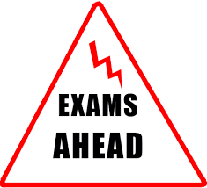
There were success in the Modules with Simon Mills (F) passing module 8, Fred Clarke (S) passing module 3 and Catherine Fraser (S) passing module 3 with credit.
Congratulations also go to Deborah Hicks who passed the Bee Health Certificate.
Dates for the module exams next year are 21st March and 14th November. Closing date for applications is 10th February and 30th September respectively.

For the Basic exam, please send your application in at least a month before you want to take it, and no later than mid-July, as the cut-off date for taking it is the end of August at the latest, and depending on the bees and weather could be the beginning of August.

Bee Health Exam: We are thinking of organising a training/refresher day in January for those who are thinking about taking the Bee Health exam. If you are interested in this day, or have any questions about the exams, please get in touch with me, bridget_knutson@yahoo.co.uk.

Bridget Knutson
Exams Secretary.

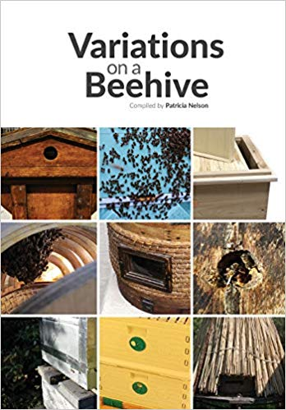
Readers will be interested to know that Tricia Nelson has recently published a book called Variations on a Beehive which is a summary of all the different types of hives and how they are used with articles from experienced beekeepers.

Well worth a read if you’re thinking about which hive to buy or whether to change to different ones.

The second in a series of articles written by Master Beekeeper Tricia Nelson.

Heating the nest
European honeybees individually are cold-blooded insects, they do not hibernate, and will die if their body temperature drops below 8’C. However as a healthy eusocial colony they make a single warm-blooded creature with a body temperature not dissimilar to our own. So how do they keep the colony warm and why?
- They are cavity dwellers, so seek shelter, which beehives provide,
- They cluster when the ambient temperature is 18’C or below.
- Their nest is wax comb (a poor conductor)
So they insulate, but how do they generate heat?
There has been some excellent research carried out by several researchers which is well described in Professor Tom Sealey’s latest book ‘The Lives of Bees’- Chapter 9, which answers many questions.

Here is a summary: A honeybee cannot fly when it’s flight muscles are below 27’C. If its individual temperature drops below 18’C it cannot even carry out its pre-flight warm up which is created by isometrically activating its flight muscles- so a lost bee in the house may need gentle warming before she can leave, and honey bees have a vested interest in always keeping their nest temperature at 18’C or above!

When flying, 80% of the energy produced by those flight muscles is lost as heat. Honeybees have learned to use this heat to warm the nest.
When there is brood, individual bees both rest on sealed brood and also enter the cells adjacent to sealed brood to warm the comb. These heater bees can and do increase their thorax temperature up to 41’C for up to 30 minutes. They consume an enormous amount of energy and they are fed by ‘tanker bees’, but the result is they have developed a system which can:
- Maintain the nursery between 34.5-35.5’C (ideal brood rearing temperature-drones at 34.5’C and workers at 35.5’C
- They can ‘run a temperature’ to kill viruses, increasing the temperature by 0.6’C
- They can ‘ball’, overheat and kill invaders.
When there is no brood the nest temperature may drop to 18’C, so temperature is a guide to what is going on in the hive. In combination with shelter, clustering and sufficient stores a colony can survive temperature of -20’C
Having said that a drop in brood nest temperature to 30’C for just a few hours allows chalkbrood to develop, an even smaller drop for a couple of hours will result in less fertile drones and less able workers.
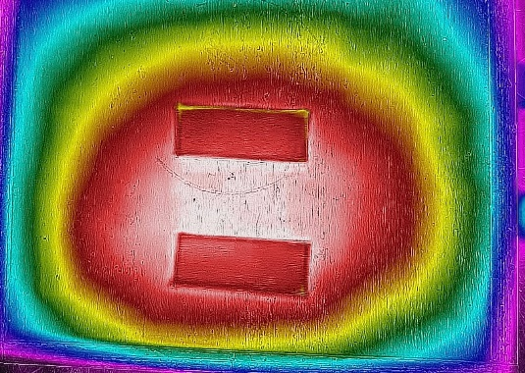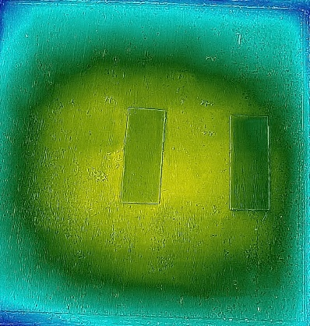
Thermal images mid-winter through the crown boards.
The left shows a colony with brood
The right shows a broodless colony

