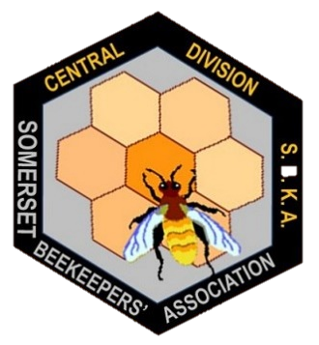BEEKEEPING FOR BEGINNERS Somerset Beekeepers Association - Central Division

*An introduction to the honey bee and its life cycle, beekeeping, equipment, pests, diseases and colony management.*

**Location:** Whitstone School, Shepton Mallet, BA4 5PF

**Dates:** Theory course - six Wednesday evenings – 7:30 – 9:00pm

02/03/22, 09/03/22, 16/03/22, 23/03/22, 30/03/22, 06/04/22

Dates for practical apiary-based sessions TBC.

**Cost:** £40

* Numbers are limited to a maximum of 30 participants.
* Associate membership of Central Division SBKA for 2022 is included in the fee.
* We can only refund fees paid in advance if we are able to resell your place.
* Book early to avoid disappointment!

Please fill in the form below and return to: [lingauthier@gmail.com](mailto:lingauthier@gmail.com)

|  |  |
| --- | --- |
| Beekeeping for Beginners Course Registration Form | |
| Name |  |
| Email address |  |
| Phone number |  |
| Address (including postcode) |  |
| Do you currently have any hives? | Yes  No |
| Date payment made on-line |  |

To secure your place, please pay £40 per participant on-line to **SBKA Central Division**; **CAF Bank**; Sort code **405240**; a/c **00013248**; reference **course**.

If you have any questions about the course, or are unable to pay on-line, please contact Lin Gauthier on the email address above.

Beekeeping for Beginners – Course Outline

|  |  |
| --- | --- |
| **Session 1 - Introduction**   * What is a honeybee? * A beekeeper has to … * Why keep bees? * How much time will it take? * How much will it cost? * Will I get stung? | **Session 2 - About the Bees**   * The castes * Honeybee Anatomy * The life cycle of the individual * The life cycle of the colony |
| **Session 3 – Equipment**   * Which hive? * Frames and Foundation * Hive Stands * Apiary Siting and Layout | **Session 4 - Principles of Bee Handling**   * Basic rules * Personal requirements * Tools of the trade * Opening the hive * What to look for * Swarming |
| **Session 5 - Bee Forage and Honey**   * Bee forage * Honey production * Harvesting the crop * Extracting and extractors * Preparation for winter | **Session 6 - Diseases, Pests, Predators and General Recap**   * Diseases * Pests and predators * Veterinary Medicines Regulations * General recap and open forum |
| **Practical Course and typical Central Division’s summer programme**   * + - Assembling Frames and Hives     - Meeting a few thousand bees     - Swarm Prevention & Control     - Making a Nucleus     - Queen Marking     - Clearing the Supers     - Honey Extraction     - Feeding & Treating | |