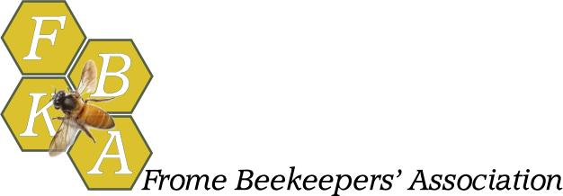

Rental of the FBKA Honey Extractor
Frome Beekeepers’ Association has a hand-cranked radial extractor which takes super frames from both National and Commercial hives. It takes 8 frames at a time. Please note, it will fit into the back of a hatchback or estate car but is quite large and heavy.
Use of the extractor
- Thoroughly clean the extractor with warm soapy water before you start, even if it appears clean. Flush with water, dry it and remember to close the tap after this stage.
- Make sure you are extracting in a bee secure space otherwise you may end up with a room full of bees with you. Covering the floor in newspaper is a good idea to soak up spills
- Taking each frame in turn, slice off the cappings with a suitable knife and place the frames in the spinner. Where possible, try to balance the frames, i.e. place full frames diagonally opposite each other
- Once full, close the lids. Never place your hand in the extractor whilst it is rotating. Turn the handle slowly at first and build up speed. It can be useful to get a second person to hold the spinner to stop it vibrating too much. Do not get carried away with the speed otherwise the frames may fall apart.
- Replace extracted frames back in the supers ready to be placed back on the hives that evening. Do not allow too much honey to accumulate at the bottom of the spinner. Use the tap every so often to take off honey into cleaned food grade buckets.
Booking the extractor
Contact __________________________________
Please phone _____________________________ or email ______________________________

Rules and Fees
- Please collect and deliver back the extractor promptly, when asked. It is often very heavily booked up during the season
- The booking fee is £35 paid in CASH (including a £30 deposit)
- If the extractor is returned in a perfectly clean, dry and undamaged state you will receive £30 back after the hire. Cleaning means no trace of honey, wax or anything else anywhere on the extractor, including inside and outside of the drum, on the cage, in the tap, on the handle, on the legs, lids etc. etc. Please dry with a cloth before returning.
- If there is any damage to the extractor, please let us know when you return it so that we can order parts and make repairs. We reserve the right to pay for repairs out of your £30 deposit.

